Documentation for FOC CA2 Assignment

# Steps Taken to install:

## Install Apache2 Server

sudo apt-get update  
  
 sudo apt-get install apache2

1. Change the group for the folder

sudo chgrp -R www-data /var/www

1. Add yourself to the group www-data

sudo usermod -a -G www-data ubuntu

1. Change the document permissions for the group

sudo chmod -R g+w /var/www

1. Install PHP

sudo apt install php7.2 php7.2-cli php7.2-mysql php7.2-json php7.2-opcache php7.2-mbstring php7.2-xml php7.2-gd php7.2-curl

1. Install Mysql

sudo apt install mysql-server

sudo mysql_secure_installation

1. Create a user and Database

**CREATE USER '*wordpress-user*'@'localhost' IDENTIFIED BY '*My1secret!*';**

**CREATE DATABASE `*wordpress-db*`;**

**GRANT ALL PRIVILEGES ON `*wordpress-db*`.* TO "*wordpress-user*"@"localhost";**

**FLUSH PRIVILEGES;**

1. Test if Mysql and Apache 2 are working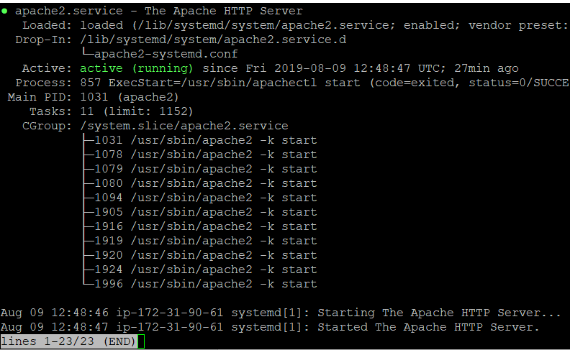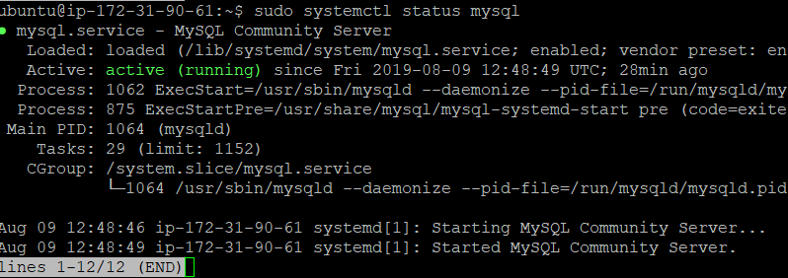

Success!!

1. Install wordpress and configure wp-config.php file

**Wget** [**https://wordpress.org/latest.tar.gz**](https://wordpress.org/latest.tar.gz)

**tar -xzf latest.tar.gz**

**cp wordpress/wp-config-sample.php wordpress/wp-config.php**

vi **wordpress/wp-config.php**

* 1. Finish the wordpress installation via browser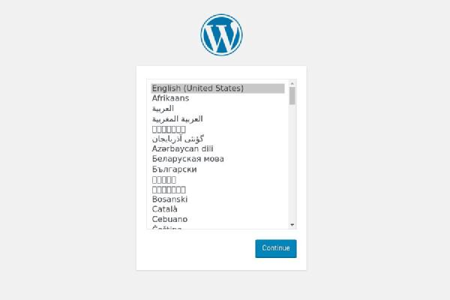

1. Import Wordpress site from Ubuntu

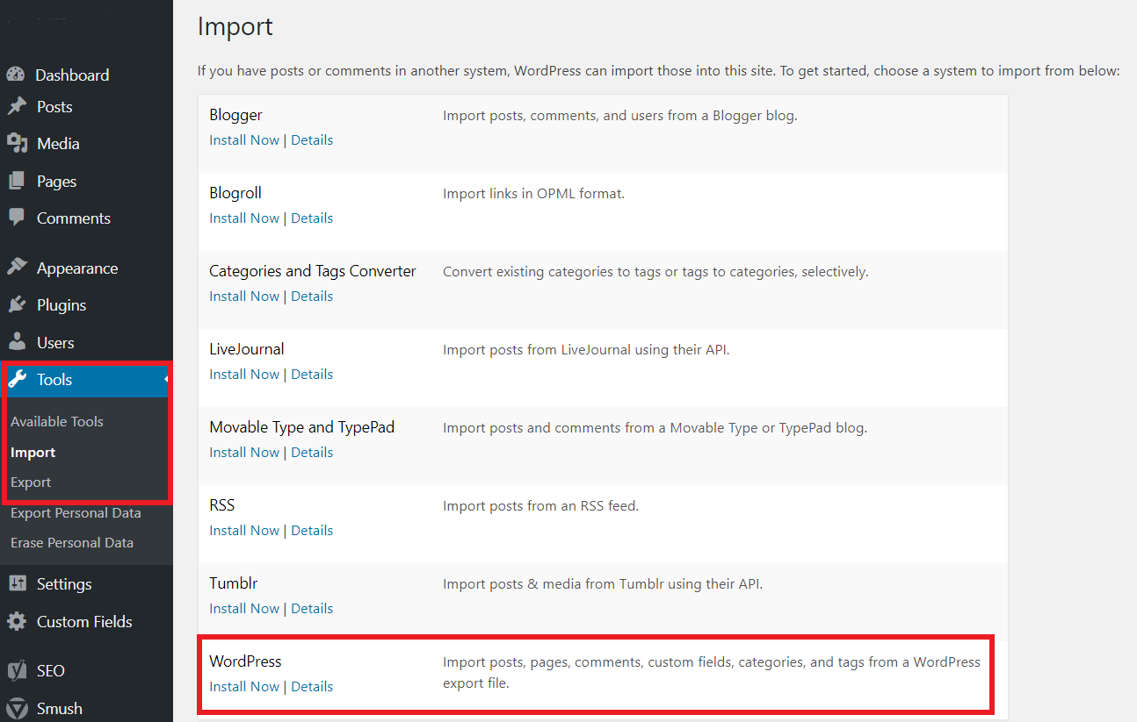

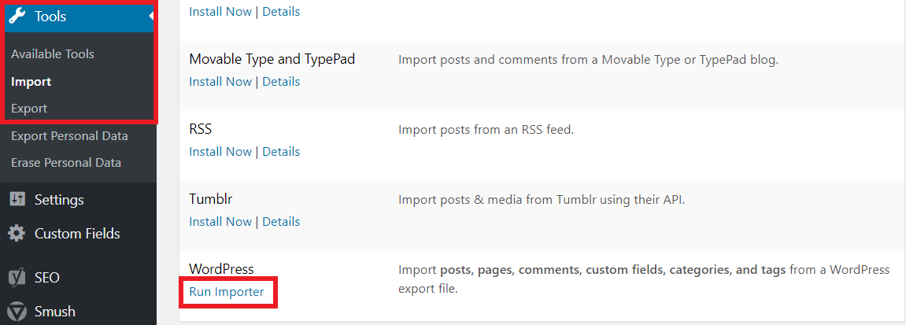

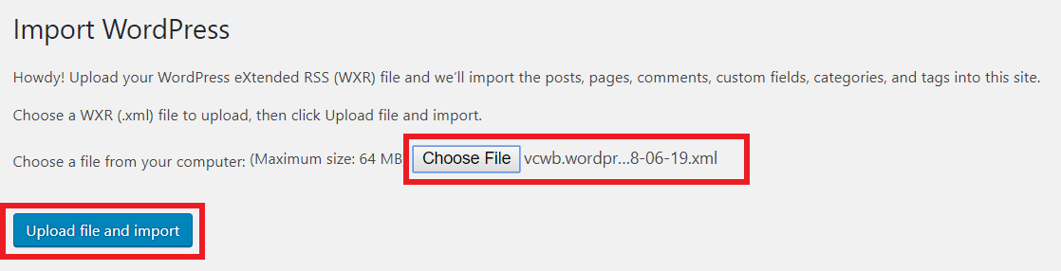

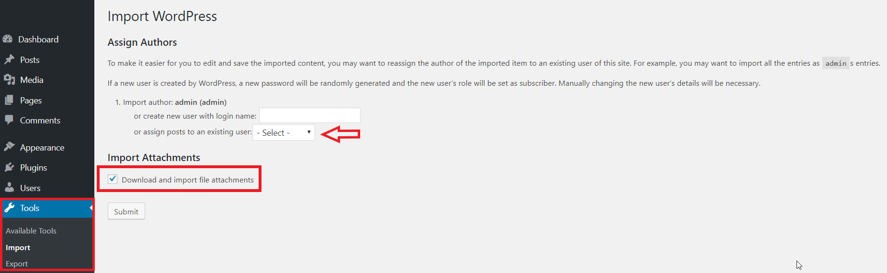

1. Finalize